Pupil Premium Strategy Statement – Clowne Junior School 2026-2029
This statement details our school’s use of pupil premium funding to help improve the attainment of our PP pupils.
It outlines our pupil premium strategy, how we intend to spend the funding in this academic year and the outcomes for PP pupils last academic year.

School overview
Detail (Accurate as of September 2023) | Data
Number of pupils in school | 317
Proportion (%) of pupil premium eligible pupils | 42%
Academic year/years that our current pupil premium strategy plan covers (3 year plans are recommended) | 2026-2029
Date this statement was published | Autumn 2026
Date on which it will be reviewed | Autumn 2029
Statement authorised by | C Newton-Wall
Pupil premium lead | Alison Carford
Governor / Trustee lead | Rev. B Taylor (As of 2025)

Funding overview
Detail | Amount
Pupil premium funding allocation this academic year | £203,966 (estimated)
Total budget for this academic year  If your school is an academy in a trust that pools this funding, state the amount available to your school this academic year | £203,966

Part A: Statement of intent
When making decisions about using Pupil Premium funding, it is important to consider the context of the school and the subsequent challenges faced. Research conducted by EEF should then be used to support decisions around the usefulness of different strategies and their value for money.

Common barriers to learning for PP children can be; home circumstances and support, underdeveloped language and communication skills, lower self-esteem and confidence and attendance and punctuality issues.

Our ultimate objectives are:
✓ To narrow the attainment gap between PP and non-PP pupils
✓ For all PP pupils in school to make or exceed national expectations
✓ To support our children’s wellbeing to enable them to lead happy and fulfilling lives

We aim to do this through:
• Ensuring that teaching and learning opportunities meet the needs of all the pupils and that quality first teaching is practised throughout school
• Ensuring that appropriate provision is made for pupils who belong to vulnerable groups, this includes ensuring that the needs of socially PP pupils are adequately assessed and addressed
• Ensuring that targeted academic support is delivered effectively and appropriately to meet the needs of children and to narrow the gap in attainment
• Providing support for families as well as our children in order to address barriers beyond the classroom
• Fostering a positive and nurturing ethos where children thrive and feel safe

Here are just some of the ways we aim to achieve our objectives:

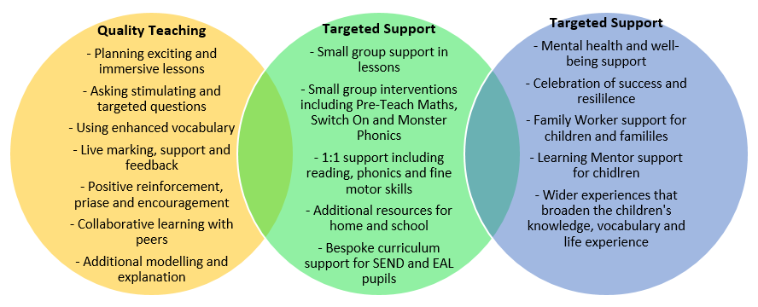

Enrichment Benchmark

- Priority access to Nurture ‘Pod Squad’
- Priority access to clubs, roles, and responsibilities around school
- Aspirational talks/visits/workshops
- Additional learning opportunities in school and wider learning visits
- Payment plans available.
- Subsidising or fully covering costs for eligible pupils.
- Targeted support with families alongside FRW.
- Bursar for the residential through a donation from previous families.
- Limited places – PP children prioritized.
- Greater range of clubs available to increase interest and uptake
- Support with transportation during competitions

Challenges
This details the key challenges to achievement that we have identified among our PP pupils.
Challenge number | Detail of challenge
1 | Writing: Assessments, observations, and discussions with pupils suggest PP pupils generally have greater difficulties with writing than their peers, including fluency in transcription skills.  On entry to year 3 2025-2026, only 25% of PP achieved Expected or above in Writing, 0% Greater Depth and 65% Working Towards. There was a 30% gap in attainment between those that were identified as PP and those identified as not PP.
2 | Attendance: Our attendance data over the last 3 years indicates that attendance among PP pupils has been between 92 - 94% compared to those non PP 94 - 96%. Even though our PP attendance scores are above national data (91%), we want to be aspirational for our PP children and increase this percentage to 96%.
3 | Reading: Assessments, observations, and discussions with pupils suggest PP pupils generally have greater difficulties with reading than their peers, including reading fluency, vocabulary and background knowledge to support language comprehension.  On entry into year 3 (2025-2026 cohort) of the 10 children that reached the WPM on fluency screening, only 1 was a PP child.  On entry into year 3 (2025-2026 cohort) of the 37 children that met age related expectations on benchmark screening only 8 were PP children.  On entry into year 3 (2025-2026 cohort) of the 15% that failed phonics test, half were PP children.  Of the 2025-2026 cohort, only 40% achieved at or above in their Reading assessment. This demonstrated a 37% gap in attainment between those that were identified as PP and those that are non PP.
4 | Wellbeing: Our assessments (including wellbeing survey), observations and discussions with pupils and families have identified social and emotional issues for some pupils, notably due to a lack of enrichment opportunities. These challenges particularly affect PP pupils, including their attainment. Our data also shows a percentage of PP children are also identified on our SEND register with EHCPs - this is greater than the percentage for pupils not eligible. Many of these pupils are supported with social and emotional needs.

Intended outcomes
This explains the outcomes we are aiming for by the end of our current strategy plan, and how we will measure whether they have been achieved.
Intended outcome | Success criteria
Progress in Reading | KS2 reading outcomes in 2029 show that more than 65% of PP pupils met the expected standard in line with National Standards.
Progress in Writing | KS2 writing outcomes in 2029 show that more than 68% of PP pupils met the expected standard in line with National Standards.
Improved social and emotional well-being as well as improve resilience and motivation | Sustained high levels of wellbeing by 2029 demonstrated by:  · qualitative data from student voice, student and parent surveys and teacher observations  · a significant increase in participation in enrichment activities, particularly among PP pupils (Trips and ASC 30% or above).  . significant increase in Motionary (KSn)
Improvement in attendance | Attendance of PP pupils to be in line with or exceeding school target of 96%

Activity in this Academic Year
This details how we intend to spend our pupil premium (and recovery premium) funding this academic year to address the challenges listed above.

Teaching (for example, CPD, recruitment and retention)
Budgeted cost: £55,000
Activity | Evidence that supports this approach | Challenge number(s) addressed
Writing, with a focus on building transcription  - Staff CPD and follow up support following adoption of new handwriting scheme, including dedicated curriculum time for explicit teaching and appropriate resourcing  - Diagnostic analysis of pupils needs to support staff subject knowledge  - Ongoing monitoring and staff support, including bespoke 1-2-1 sessions with staff | Focus: Develop pupils’ transcription through extensive practice – R2 EEF Improving Literacy in KS2  Our key areas for development include:  - ‘Fluent writing supports composition because pupils’ cognitive resources are freed from focusing on handwriting,... and can be redirected towards writing composition. Extensive practice, supported by effective feedback, is required to develop fluent transcription skills.  - Monitor pupils’ handwriting to ensure accurate letter formation habits, providing effective feedback to promote efficient and fluent handwriting.’  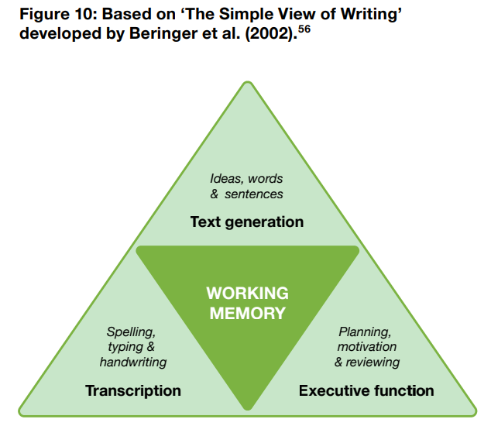 | 1
Develop pupils’ fluency through: —guided oral reading instruction—teachers model fluent reading, then pupils read the same text aloud with appropriate feedback; and —repeated reading— pupils re-read a short and meaningful passage a set number of times or until they reach a suitable level of fluency.  Teach specific strategies that pupils can apply to monitor and overcome barriers to comprehension. These include: —prediction (based on text content and context); —questioning; —clarifying; —summarising; and —activating prior knowledge. | Focus: Recommendation 2 Support pupils to develop fluent reading capabilities  Improving Literacy KS2 guidance report  Fluent reading supports comprehension because pupils’ cognitive resources can be redirected from focusing on word recognition to comprehending the text. •  Actively teaching reading fluency is important for all pupils, with those judged to be struggling likely to benefit from targeted support. When considering targeted support, diagnosis of the specific issues should be the first step before selecting an intervention.31 For example, it is important to check for weaknesses in decoding or comprehension before concluding that reading fluency should be the primary focus of targeted support.  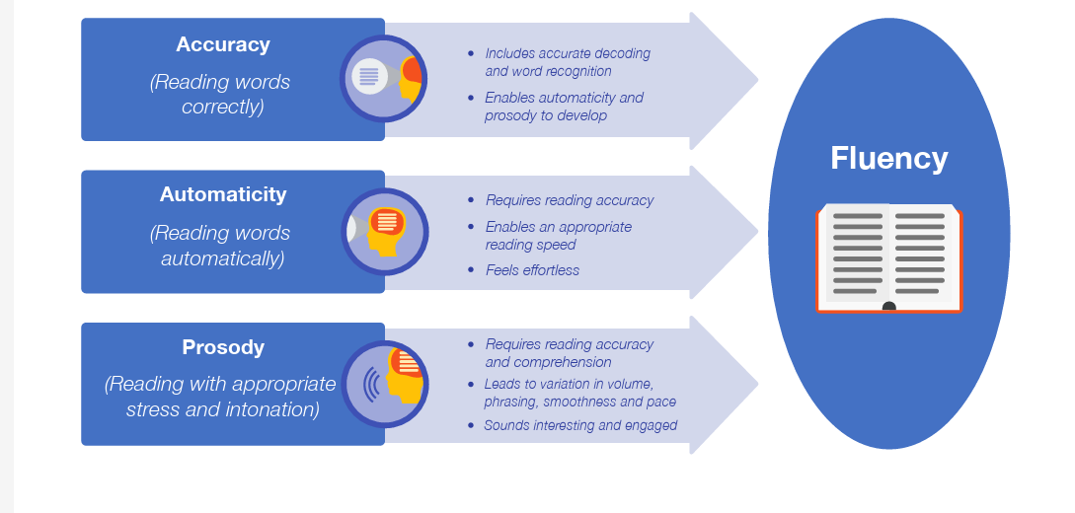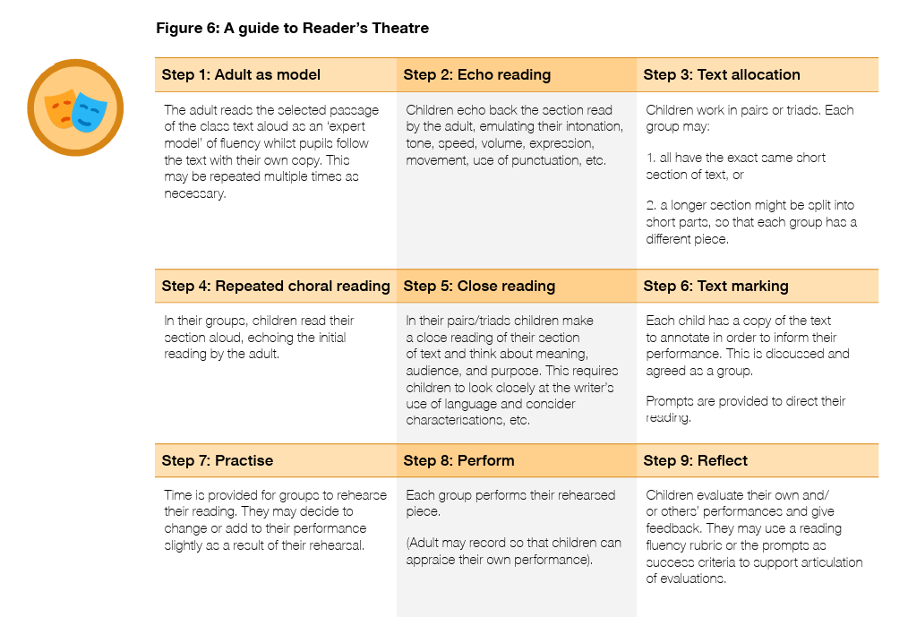 | 3

Targeted academic support (for example, tutoring, one-to-one support, structured interventions)
Budgeted cost: £45,260
Activity | Evidence that supports this approach | Challenge number(s) addressed
Social and Emotional Learning – Pupil Wellbeing  - Identification of needs through emotional screening tool  - A range of interventions focusing on SEL needs, including 1-2-1 Emotional, Lego Therapy, Nurture Group, Drawing and Talking, Social Skills, Sensory Circuits and OPAL.  - Expert Delivery: Ensure high quality provision with staff development  - Audit provision based on TARGET framework to ensure maximum impact (Timing; Assessment; Resourcing; Give it time; Expert delivery; Teacher links) - ensure fidelity | Social and emotional learning | EEF  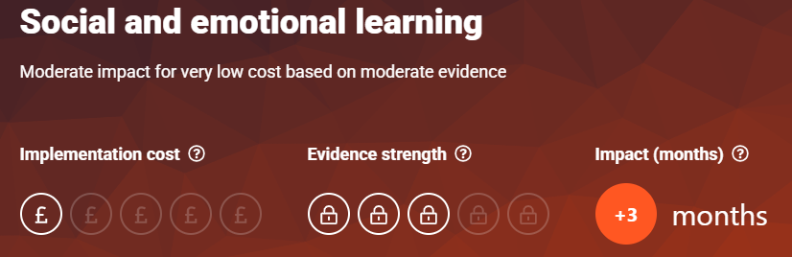  Focus: Teach SEL skills explicitly and – Recommendation 1 EEF Social and Emotional Learning Guidance Report  Use a range of strategies to teach key skills, both in 1-2-1 provision matched to a pupil’s areas of need  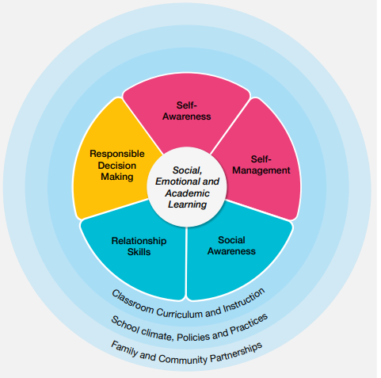 | 4

Wider strategies (for example, related to attendance, behaviour, wellbeing)
Budgeted cost: £124,300
Activity | Evidence that supports this approach | Challenge number(s) addressed
Clear communication between school and parent through online mediums – class dojo, termly newsletter, emails.  Attendance – protocols in place when attendance issues lead by our Attendance Lead.  - Family support worker contact - School works alongside parents and carers to support home/school life.  - Flowchart of communication if attendance drops e.g. email to parents, FRW, attendance panel meeting with parenst/carers.  Magic Breakfast  - Free breakfast for all to encourage punctuality and readiness to learn.  Interventions  - Offering more structured, evidence-based programmes can help to develop positive behaviour and consistency where needs are greater. Such examples include, Fluency groups, phonics (bespoke, ph 4 & 5), bespoke writing, LEAP/VIP, Maths satellite groups and Ready, Set, Read.  Learning plans – shared termly with parents.  - Start by assessing needs and talking to parents about what would help them support learning: targeting is likely to be needed to use resources effectively and avoid widening gaps. • Communicate carefully to avoid stigmatising, blaming, or discouraging parents. Focus on building parents’ efficacy— that they are equal partners and can make a difference. | - Focus:  - Working with Parents to Support Children's Learning | EEF - effective parental engagement can lead to learning gains of +3 months over the course of a year. Getting your child ready to start school.  - There is some evidence of promise for parental communication and engagement approaches and responsive interventions that meet the individual needs of the pupils.  - The interventions that show promise take a holistic approach in understanding pupils and their specific need, and address the specific barriers to attendance that have been identified. For example, one programme found to have a positive impact on attendance used several different approaches depending on the needs of pupils, including a team to monitor and track attendance, parental communication, and motivation systems. | 2
Social and Emotional Learning – Pupil Wellbeing  - Audit current pupil need and identify high leverage focus areas  - Align work with our feeder infant school  - Review current SEL curriculum, values and behaviour and rewards systems | Focus: Reinforce SEL skills through whole-school ethos and activities – Recommendation 5 EEF Social and Emotional Learning Guidance Report  • Establish schoolwide norms, expectations and routines that support children’s social and emotional development.  • Align your school’s behaviour and anti-bullying policies with SEL.  Focus: Integrate and model SEL skills through everyday teaching - Recommendation 2 EEF Social and Emotional Learning Guidance Report  • Model the social and emotional behaviours you want children to adopt.  • Give specific and focused praise when children display SEL skills.  • Do not rely on ‘crisis moments’ for teaching skills.  • Embed SEL teaching across a range of subject areas: literacy, history, drama and PE all provide good opportunities to link to SEL.  • Use simple ground-rules in groupwork and classroom discussion to reinforce SEL skills. | 4

Part B: Review of the previous academic year

PPSS 23-26 REVIEW
Challenge number | Detail of challenge | Review | Impact
1 | Limited exposure to books leading to difficulties with fundamental writing skills. | Implementation of 6 step writing sequence which includes analysis and SPAG element to target writing skills. Four book studies covered, Non-fiction and a range of genres covered including play scripts and poetry. Class Reader plus  D.E.A.R. All children have individual reading books. | Writing 2025 KS2 SATs 68%  (60% National)  Writing 2026 KS2 SATs 77%  (59% National)
2 | Limited exposure to books and support with phonics and early reading leading to difficulties with fundamental reading skills | Targeted phonics support interventions (Bespoke and Phases 4 & 5). Four book studies covered, Non-fiction and a range of genres covered including play scripts and poetry. Class Reader plus D.E.A.R. All children have individual reading books. | Reading 2025 KS2 SATs 65%  (63% National)  Reading 2026 KS2 SATs 85%  (63% National)
3 | Social and emotional difficulties including self-esteem, motivation, resilience and social interaction. | Targeted work from Learning Mentor, Pod squad (nurture style provision), Lego Therapy, Drawing and Talking, use of sensory audits and sensory room. PSHE curriculum – SCARF scheme implemented. Wellbeing ambassadors and Smilers established. Clowne values. | Children acquire the skills to be confident and tolerant learners becoming well rounded adults and a positive member of a diverse, multicultural society, more emotionally literate, challenge themselves and persevere, build positive relationships and have an improved understanding of their mental health.
4 | Limited early childhood experiences and opportunities for learning, play, language acquisition and life skills. | Reduction in residential to 2 year groups to support families fund the trips, payment plans available, subsidising or fully covering costs for eligible pupils, targeted support with families alongside FRW, limited places – PP children prioritized, greater range of clubs available to increase interest and uptake, support with transportation during competitions, targeted support with families alongside FRW. OPAL established. | 27% uptake on ALL residentials (20% 2023)  26% uptake on ASC  (19% 2023)  99% uptake on ALL school trips  (95% 2023)
5 | Attendance of pupils in receipt of pupil premium is below that of peers and a greater proportion are classed as persistent absentees. | FSW targeted involvement, flowchart of communication with parents, Magic breakfast, targeted intervention where need is greater, learning plans shared termly. | 92.6% attendance (Above national average)

Outcomes for disadvantaged pupils

Pupil Premium children were above the national average in attainment in Reading, Writing and Maths over a 3 year average.
Pupil Premium 2025 cohort Progress Data.
KS1 Data | EXS | GD | KS2 Data | EXS | GD
Reading | 44% | 0% | Reading | 64.7% | 29%
Writing | 28% | 0% | Writing | 67.6% | 11%
Maths | 40% | 4% | Maths | 82.4% | 20%

Pupil Premium 2026 cohort Progress Data
KS1 Data | EXS | GD | KS2 Data | EXS | GD
Reading | 45% | 0% | Reading | 85% | 21%
Writing | 41% | 0% | Writing | 77% | 5%
Maths | 41% | 0% | Maths | 87% | 15%

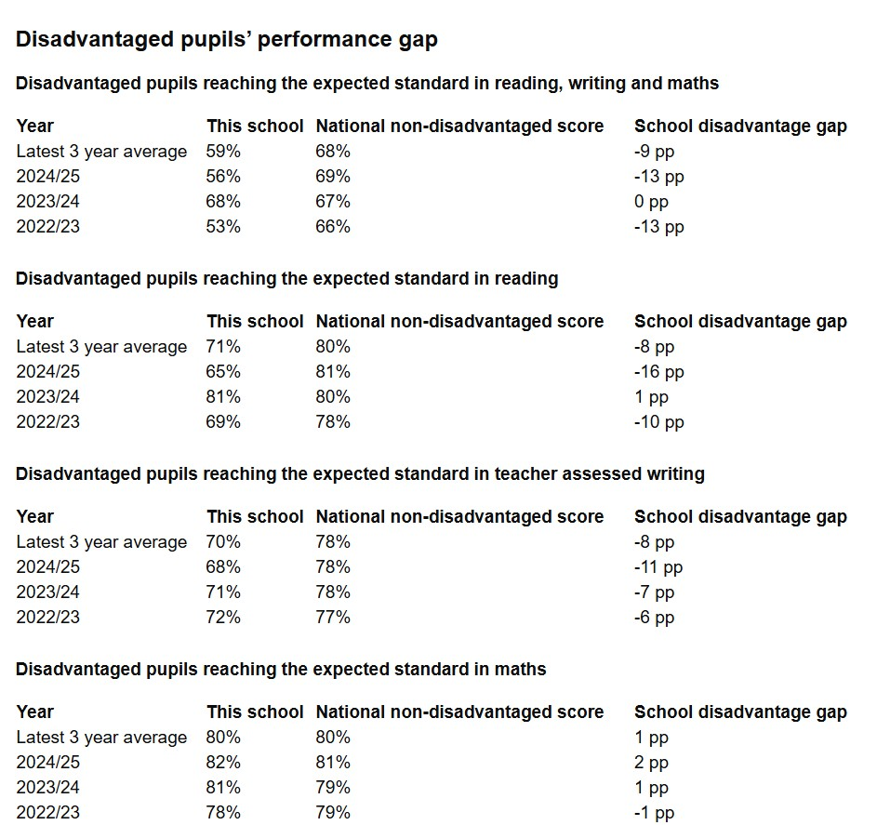

We have analysed the performance of our school’s disadvantaged pupils during the
previous academic year, drawing on national assessment data.

To help us gauge the performance of our disadvantaged pupils we compared their
results to
those for disadvantaged and non
-
disadvantaged pupils at national level and to
results achieved by our non
-
disadvantaged pupils.

Based on all the information above, the performance of our disadvantaged pupils
exceeded

expectations.

